🧪 LAB 1: Replace Error Messages in Logs
Create log file
cat > app.log << EOF
INFO: Service started
ERROR: Database connection failed
INFO: User logged in
ERROR: API timeout
EOF
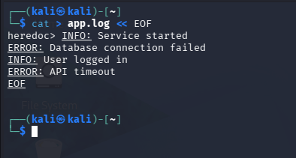
Task
Replace all ERROR with WARNING
sed 's/ERROR/WARNING/g' app.log
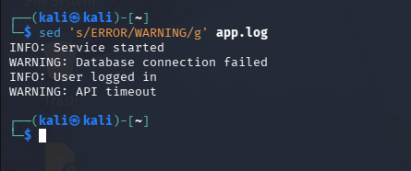
💡 Simple Memory Trick
cat > file.txt << EOF
Write content here
EOF
means:
👉 "Create file and keep writing until EOF appears."
This technique is called a Here Document (Heredoc) and is used a lot in shell scripting and DevOps automation. 🚀

🧪 LAB 2: Mask IP Addresses (Security)
Create file
cat > access.log << EOF
User connected from 192.168.1.10
User connected from 10.0.0.5
EOF
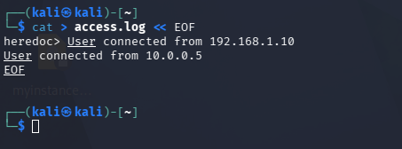
Task
Hide IP addresses
sed 's/[0-9]\+\.[0-9]\+\.[0-9]\+\.[0-9]\+/XXX.XXX.XXX.XXX/g' access.log
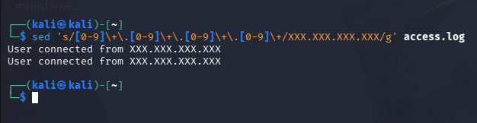
Real-world use:
Before sharing logs with customers or teams.

🧪 LAB 3: Update Configuration File
Create config
cat > app.conf << EOF
PORT=8080
DEBUG=true
EOF
Task
Change port to 9090
sed 's/PORT=8080/PORT=9090/' app.conf
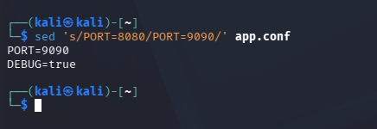
Real-world use:
Automating server configuration changes.

🧪 LAB 4: Delete Comment Lines
Create file
cat > config.txt << EOF
# Database settings
DB_HOST=localhost
# Debug mode
DEBUG=true
EOF
Task
Remove comment lines
sed '/^#/d' config.txt
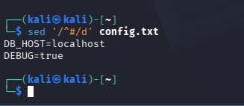
^ matches the start of a line.
d means delete

🧪 LAB 5: Extract Failed Login Entries
Create file
cat > auth.log << EOF
SUCCESS user1
FAILED user2
SUCCESS user3
FAILED user4
EOF
Task
Show only failed entries
sed -n '/FAILED/p' auth.log
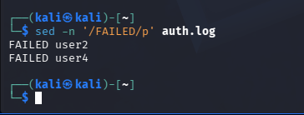
Printing (-n ... p): suppressing default output and printing only selected lines.

🧪 LAB 6: Add Timestamp Prefix
Create file
echo "Server Started" > service.log
Task
Add prefix
sed 's/^/[2025-08-18] /' service.log
Output:
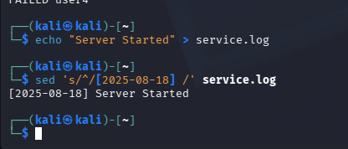

🧪 LAB 7: Simulate Production Log Cleanup
Create file
cat > prod.log << EOF
INFO Started
DEBUG Variable x=5
INFO Running
DEBUG Connection test
EOF
Task
Remove DEBUG lines
sed '/DEBUG/d' prod.log
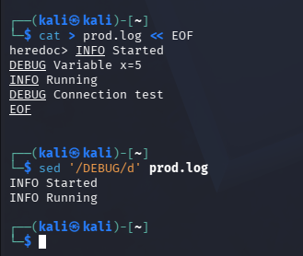
Real-world use:
Cleaning noisy logs before analysis.

🧪 LAB 8: Bulk Username Modification
Create file
cat > users.txt << EOF
john
alice
bob
EOF
Task
Add company domain
sed 's/$/@company.com/' users.txt
Output:
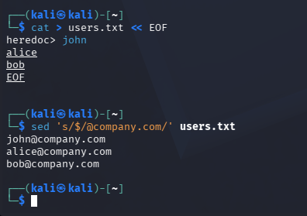

🚀 BEST LAB FOR LINKEDIN
👉 LAB 7: Production Log Cleanup
- Create log file
- Remove DEBUG entries
- Show before/after output
- Explain how DevOps teams clean logs before troubleshooting
That demonstrates:
✅ Linux
✅ Log Analysis
✅ Automation
✅ Troubleshooting mindset
all in one small lab.
🧪 Goal
Imagine your application generates logs like:
INFO Started
DEBUG Variable x=5
INFO Running
DEBUG Connection test
ERROR Database failed
When troubleshooting, DevOps engineers often remove noisy DEBUG lines and focus on important logs.

⚙️ Step 1: Create the log file
cat > prod.log << EOF
INFO Started
DEBUG Variable x=5
INFO Running
DEBUG Connection test
ERROR Database failed
EOF
Verify:
cat prod.log
Output:
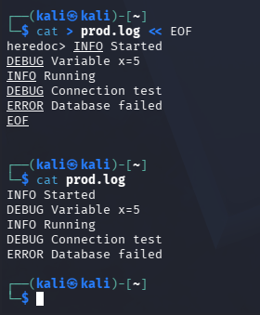

🔍 Step 2: Understand the problem
Not all logs are useful.
Log Type | Meaning
INFO | Normal operation
DEBUG | Developer troubleshooting
ERROR | Something failed
During incident analysis, DEBUG logs can create noise.

🧹 Step 3: Remove DEBUG lines
Run:
sed '/DEBUG/d' prod.log
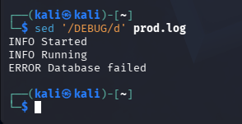

🧠 Break it down
sed '/DEBUG/d' prod.log
Part | Meaning
sed | Stream editor
/DEBUG/ | Find lines containing DEBUG
d | Delete those lines
prod.log | File to process

🎯 Output
INFO Started
INFO Running
ERROR Database failed
DEBUG lines disappeared 🎉

💾 Step 4: Save cleaned logs
The previous command only displays output.
To save:
sed '/DEBUG/d' prod.log > clean.log
Verify:
cat clean.log
Output:
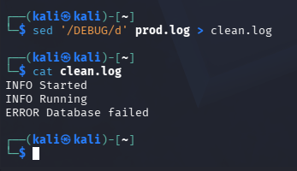
🚨 Step 5: Focus only on errors
Now imagine a production incident.
Show only ERROR:
grep ERROR clean.log
Output:
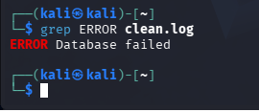
🌍 Real-world Scenario
Imagine a website is down.
A log file contains:
DEBUG User clicked login
DEBUG API request sent
INFO Service running
ERROR Database connection failed
DEBUG Retry attempt
As an engineer, you don't want to read hundreds of DEBUG messages.
You clean the logs:
sed '/DEBUG/d' app.log
Then investigate:
grep ERROR app.log
👉 Root cause becomes obvious.
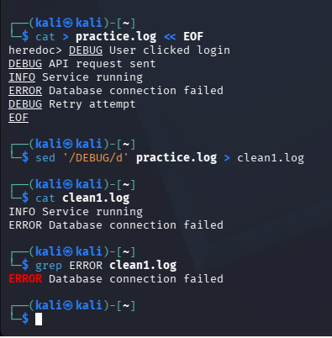

🎤 Interview Answer
"I used sed to remove DEBUG entries from application logs, making it easier to focus on INFO and ERROR messages during troubleshooting. This is a common log-cleanup technique used before incident analysis."

🚀 Bonus Challenge
Can you write a command that removes both:
DEBUG
INFO
and shows only:
ERROR Database failed
